160th Bedford Amateur Regatta – Saturday 9th May 2026
Competitor Notes
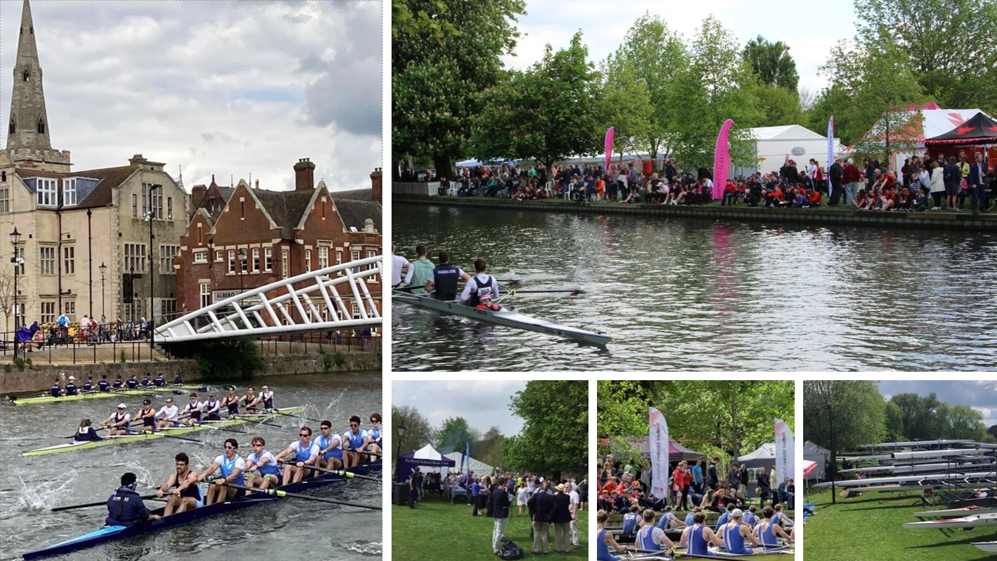

Dear Competitors and Coaches,
Thank you for your entry to the Bedford Amateur Regatta. Please find attached the details of the draw. If you have any issues with your entries, contact the Regatta Entries Secretary immediately, preferably via email at entries@bedfordregatta.co.uk.
We are pleased to have a very large entry this year. As such, it is essential that crews are fully briefed and prepared to race at the scheduled time. All first-round races have been arranged to allow for crews and boats to double up, provided this information has been entered into the British Rowing Online Entry System (BROE2). Due to this, there is very limited opportunity for rescheduling these races. Crews should expect the rules of racing to be strictly enforced and should aim to arrive at the start well in advance. If rescheduling is required for later rounds, it must be confirmed with Regatta Control, located near the finish tent. To reschedule a race, a representative from both crews must be present at Regatta Control.
Please read the following important notes and ensure your crew members are informed. These guidelines will help ensure the day runs smoothly, safely, and enjoyably.
REGATTA CONTROL is located next to the finish line, beside the Suspension Bridge.
Scratchings:
Please inform the Entries Secretary, as soon as possible, if you wish to scratch before the day of the Regatta. On the day, notify Regatta Control as soon as possible to avoid crews boating unnecessarily.
Substitutions:
Substitutions may be made online via BROE2 before race day or through Regatta Control before a crew’s first race. After the first race, substitutions will only be allowed for medical reasons and must be authorised by the Chair of the Race Committee via Regatta Control.
Racing Licenses:
Ensure crew composition is accurate at the start of racing. Coaches or crew representatives should verify the entry when collecting race numbers. Random checks may be made during boating.
Getting to the Regatta:
From the A1, take Cardington Road into town, passing the Kingfisher Hotel, the pyramid-shaped swimming pool, and Tesco. After the Tesco roundabout, filter into the right-hand lane for the A5140, signposted towards Cambridge. At the next roundabout, take the fourth exit onto A5140 Longholme Way. Cross the river, then take the first left onto the Embankment. Immediately turn left again over the white bridge onto Longholme Island if you have a trailer.

Parking:
Visiting competitors and spectators should park in Mill Meadows, just off Cardington Road, where ample space is available. The nearest postcode for the Regatta car park is MK42 0BX, or use the what3words location "occurs.same.analogy."
Boat Trailers:
The Regatta is grateful to the local Borough Council for allowing us to use their facilities, particularly the area around Longholme Lake, which is usually reserved for trailer parking and boat storage. Due to recent heavy rainfall, the grass area between Longholme Lake and the river is soft, so we are minimizing trailer parking beside the lake. We request that clubs park trailers on the embankment, uncouple towing vehicles, and park them in the Regatta car park to minimize the impact on council-owned land. Regatta representatives will be on hand to assist with parking.
Please note that no vehicles are allowed to park on the grass between the Embankment and the river. Boats can be left on trestles, but there is very limited trailer parking on the road. Arrive early, as it will get busy.
Access to Regatta Site:
The Regatta site is accessible via the Embankment on the Friday before the event. However, please note that there will be NO physical security available, and the Regatta takes no responsibility for damage to trailers or equipment.
Inspection of Boats:
Clubs are responsible for following the British Rowing RowSafe best practices. Ensure your boats comply with the latest guidelines, which are available on both the Regatta and British Rowing websites. The Control Commission will conduct spot checks; boats failing to pass inspection will not be allowed to race.
Oar Storage:
Limited oar racking is available in the boating area. Otherwise, oars should be stored in trailers or similar when not in use. Bring oars to the landing stages only as you prepare to go afloat, and remove them promptly after de-boating.
Coxswains:
Coxswains must weigh in at Regatta Control before their first race and will receive a ticket, which must be available if requested by an umpire. Spot checks will be made, and crews may be asked to call at a landing stage for this check. Coxswains should provide their own deadweight where necessary, and appropriate buoyancy aids/life jackets must be worn. For “front-loader” boats, coxswains must wear manually operated gas inflation life jackets.

Race Numbers:
Paper numbers will be issued to be worn on both the Coxswain’s and Bow’s racing tops. Numbers and competitor badges can be collected from Regatta Control from 07:00 on race day. Race numbers will not be issued until all fees have been paid. Ensure the correct number is displayed for your relevant event, especially if doubling up.
Racing Order:
Races will be held in the order shown in the programme, where possible. Please assist us by arriving at the start at least 10 minutes before your scheduled race time. BYES will not be required to be rowed.
Attaching to Stakeboats:
Coaches and clubs should ensure that crews are competent in attaching to stakeboats. Crews may be disqualified if the Umpires determine they are not able to attach within a reasonable time.
Regatta Enclosure:
The Regatta Enclosure, located adjacent to the Suspension Bridge, provides refreshments, toilets, and a bar for competitors and spectators, with ample seating. Competitors will receive wristbands for access, while spectators must pay a modest entry fee.
Prize Giving:
Winners should present their British Rowing membership cards at Regatta Control to receive a docket. This can be exchanged for tankards at the Prize Tent in the Enclosure.
Photography:
As the Regatta is held in a public location, photographs may be taken by professional photographers or members of the public. All photographers should follow the Safeguarding and Photography policy of British Rowing. Report any suspected breaches to the Welfare Officer via Regatta Control.
Drones:
The use of drones is not permitted at the Regatta. Please be reminded that there are strict government regulations regarding drones in built-up areas and near large outdoor events.
Camping and Hotels:
Unfortunately, no camping facilities are available. However, there are numerous hotels in the area. You can find more information online.
Tents/Gazebos:
An area has been designated for visiting Schools and Clubs to erect tents/gazebos. Please contact the Regatta Entries Secretary to reserve your space. All spaces must be booked and paid for in advance. For health and safety reasons, no barbecues are allowed outside the Regatta Enclosure.
Rubbish:
Please dispose of rubbish in the bins provided or take it home with you. Let’s all work together to keep the Regatta site clean and tidy.
Cancellation Policy:
In the event of cancellation, we will endeavour to refund entry fees on a pro-rata basis once unavoidable costs have been covered. For partial cancellations or cancellation of specific events, no refunds will be provided.
Coaches Following Crews:
The towpath can become quite congested, especially near bridges. Therefore, we kindly request that each crew is accompanied by only one coach during their race. Beyond Bedford Rowing Club, the path narrows significantly, so please take extra care when cycling in these areas.
We hope you have a successful and enjoyable day.
Best regards,
Hugh Maltby
Hon. Regatta Secretary

Safety Notes: Bedford Amateur Regatta follows the British Rowing RowSafe Guide. All competing clubs and competitors must be familiar with and adhere to the safety guidelines for their own safety. Regatta Control is located next to the finish line and can be reached throughout the event at 07824 308099, or by asking any Regatta official with a radio.
Medical Provision is provided by Ambulance Response Ltd near the entrance to the enclosure. Safety and rescue craft will be on duty during racing hours and may be summoned by any Regatta official via Regatta Control.

